Abstract:

Security has been playing a key role in many of our places like offices, institutions, libraries, laboratories etc. in order to keep our data confidentially so that no other unauthorized person could have an access on them. Nowadays, at every point of time, we need security systems for protection of valuable data and even money. This paper presents a fingerprint based door opening system which provides security which can be used for many banks, institutes and various organizations etc..,. There are other methods of verifying authentication through password, RFID but this method is most efficient and reliable. To provide perfect security to the bank lockers and to make the work easier, this project is taking help of two different technologies viz. EMBEDDED SYSTEMS and BIOMETRICS. Unauthorized access is prohibited by designing a lock that stores the fingerprints of one or more authorized users. Fingerprint is sensed by sensor and is validated for authentication. If the fingerprint matches, the door will be opened automatically otherwise the buzzer connected to an audio amplifier will be activated so that the people near the surroundings will get an alert.

Chapter 1
INTRODUCTION

Security is of primary concern and in this busy, competitive world, human cannot find ways to provide security to his confidential belongings manually. Instead, he finds an alternative which can provide a full fledged security as well as atomized. In the ubiquitous network society, where individuals can easily access their information anytime and anywhere, people are also faced with the risk that others can easily access the same information anytime and anywhere. Because of this risk, personal identification technology, which can distinguish between registered legitimate users and imposters, is now generating interest. Generally passwords, identification cards and PIN verification techniques are being used but the disadvantage is that the passwords could be hacked and a card may be stolen or lost. The most secured system is fingerprint recognition because a fingerprint of one person never matches the other. Biometrics studies commonly include fingerprint, face, iris, voice, signature, and hand geometry recognition and verification. Many other modalities are in various stages of development and assessment. Among these available biometric traits fingerprint proves to be one of the best traits providing good mismatch ratio, high accurate in terms of security and also reliable.

Chapter 2

LITERATURE SURVEY
Various attempts are made for providing security for all domiciles. Up to date, complete security is not discovered.

Lock and Key System:

First step towards security was Lock and key system. Security protocol followed in this system was “Single key for a single lock”. Initially, this system was considered to provide atmost security. But this belief was soon proved wrong by the fact that multiple keys can be easily made for a single lock. Hence this system is an outdated system to provide security.
Password Authentication:

Next level of Security used password as an authenticating tool. This system stores password of authenticated users for the purpose of validation. System using password authentication provides considerable security to the users as it acts as a secret of authorized users. This system also have a pitfall that password can be acquired by unauthorized user by continuously trying all the possible combinations. This is also one among the hundreds of attempt made for providing security.

Authentication by RFID card:
Next level of technological development for providing security was authentication by RFID card. This system enriched the level of security. Access is granted only for the user whose RFID code matches with the authorized code. This system also have disadvantage of duplication of RFID card and anyone who possess this card can unlock the door.

SCOPE

In future, alarm will be introduced. When intruder tries to break the door, the vibration is sensed by sensor which makes an alarm. This will inform the neighbors about intruders and this will help to take further action to prevent intruder from entering.

PROPOSED METHODOLOGY

Our proposed system overcomes all the security problems in existing system and provides high security and efficiency. This is a perfect/optimal solution for saving/protecting one from the hassle of stolen/lost key or an unauthorized entry. Fingerprint is a boon solution for these problems which provides high level of recognition accuracy. The skin on our palms and soles exhibits a flow like pattern of ridges called friction ridges. The pattern of friction ridges on each finger is unique and immutable. This makes fingerprint a unique identification for everyone. Fingerprint door lock incorporates the proven technology. Fingerprint scanner scans the fingerprints of users and used for ensuring authentication. Fingerprint scanning is more accurate and cost effective method and duplication is virtually impossible. A Fingerprint recognition system can easily perform verification. In verification, the system compares an input fingerprint to the enrolled fingerprint of a specific user to determine if they are from the same finger. Now the security of our home/office is literally in our hands or rather on our fingertips. After the scanning has been completed, user has to enter the password to open his locker with the help of a keypad. Immediately the locker will be opened. After the work has been completed if key is pressed again with help of keypad the locker door will be closed again. If an unauthorized person tries to scan his fingerprint image then an indication will be given by a buzzer which is interfaced to the controller and also if wrong password is entered by the user again indication will be given by the buzzer. The current user instead of him/her can make a new person as the user of the same locker by new registration process and the old user’s fingerprint image will be deleted. Option for changing the password is also available.

Chapter 3
3.1 BLOCK DIAGRAM
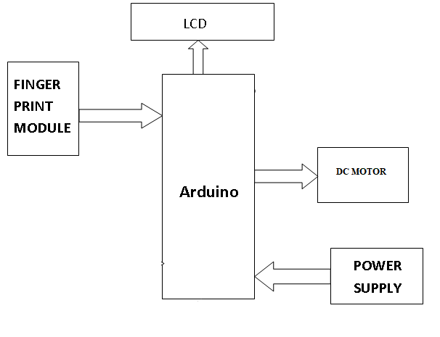
fig 3.1: Block Diagram

3.2 SOFTWARE AND HARDWARE REQUIREMENTS

Here shows the target environment (hardware and software) for which the system is being developed.

DETAILS OF HARDWARE
- Power Supply : 12V DC
- Micro controller : Arduino
- DC Motor
- RS 232 converter : MAX 232
- Finger print reader

DETAILS OF SOFTWARE
- Arduino Suite
- C Programming

Chapter 4
CIRCUIT DESIGN
4.1 HARDWARE SCHEMATIC

Arduino Atmega 328 Microcontroller

Arduino UNO

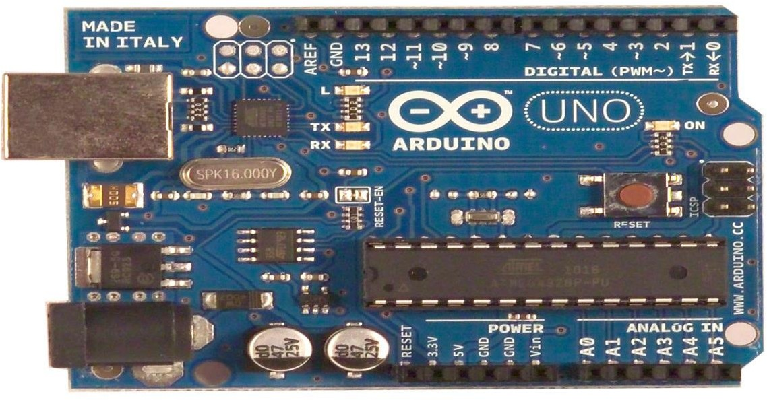

Fig 3.1 Arduino UNO

The Arduino Uno is a microcontroller board based on the ATmega328. It has 14 digital input/output pins (of which 6 can be used as PWM outputs), 6 analog inputs, a 16 MHz crystal oscillator, a USB connection, a power jack, an ICSP header, and a reset button. It contains everything needed to support the microcontroller; simply connect it to a computer with a USB cable or power it with a AC-to-DC adapter or battery to get started. The Uno differs from all preceding boards in that it does not use the FTDI USB-to-serial driver chip. Instead, it features the Atmega8U2 programmed as a USB-to serial converter. "Uno" means one in Italian and is named to mark the upcoming release of Arduino 1.0. The Uno and version1.0 will be the reference versions of Arduino, moving forward. The Uno is the latest in a series of USB Arduino boards, and the reference model for the Arduino platform.

Technical Specifications

    - Microcontroller ATmega328
    - Operating Voltage 5V
    - Input Voltage (recommended) 7-12V
    - Input Voltage (limits) 6-20V
    - Digital I/O Pins 14 (of which 6 provide PWM output)
    - Analog Input Pins 6
    - DC Current per I/O Pin 40 mA
    - DC Current for 3.3V Pin 50 mA
    - Flash Memory 32 KB of which 0.5 KB used by boot loader
    - SRAM 2 KB
    - EEPROM 1 KB
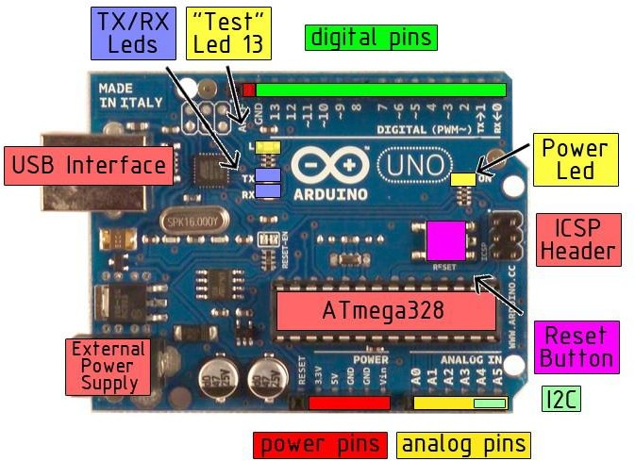

Fig 3.2 Arduino Specifications

POWER

The Arduino Uno can be powered via the USB connection or with an external power supply. The power source is selected automatically. External (non-USB) power can come either from an AC- to-DC adapter (wall-wart) or battery. The adapter can be connected by plugging a 2.1mm center- positive plug into the board's power jack. Leads from a battery can be inserted in the Gnd and Vin pin headers of the POWER connector. The board can operate on an external supply of 6 to 20 volts. If supplied with less than 7V, however, the 5Vpin may supply less than five volts and the board may be unstable. If using more than 12V, the voltage regulator may overheat and damage the board. The recommended range is 7 to 12 volts. The power pins are as follows:

    - VIN. The input voltage to the Arduino board when it's using an external power source (as opposed to5 volts from the USB connection or other regulated power source). You can supply voltage through this pin, or, if supplying voltage via the power jack, access it through this pin.
    - 5V. The regulated power supply used to power the microcontroller and other components on the board. This can come either from VIN via an on-board regulator, or be supplied by USB or another regulated 5V supply.
    - 3V3. A 3.3 volt supply generated by the on-board regulator. Maximum current draw is 50 mA.
    - GND. Ground pins.

The Atmega328 has 32 KB of flash memory for storing code (of which 0,5 KB is used for the boot loader); It has also 2 KB of SRAM and 1 KB of EEPROM (which can be read and written with the EEPROM library). Each of the 14 digital pins on the Uno can be used as an input or output, using pin Mode(), digital Write(), and digital Read() functions. They operate at 5 volts. Each pin can provide or receive a maximum of 40 mA and has an internal pull-up resistor (disconnected by default) of 20-50kOhms. In addition, some pins have specialized functions:

Serial: 0 (RX) and 1 (TX). Used to receive (RX) and transmit (TX) TTL serial data. These pins are connected to the corresponding pins of the ATmega8U2 USB-to-TTL Serial chip.

Software Description:

Arduino IDE
Arduino is an open-source electronics platform based on easy-to-use hardware and software. Arduino boards are able to read inputs - light on a sensor, a finger on a button, or a Twitter message - and turn it into an output - activating a motor, turning on an LED, publishing something online. You can tell your board what to do by sending a set of instructions to the microcontroller on the board. To do so you use the Arduino programming language (based on Wiring), and the Arduino Software (IDE), based on Processing.
The Arduino software is easy-to-use for beginners, yet flexible enough for advanced users. It runs on Mac, Windows, and Linux. Teachers and students use it to build low cost scientific instruments, to prove chemistry and physics principles, or to get started with programming and robotics. Designers and architects build interactive prototypes, musicians and artists use it for installations and to experiment with new musical instruments. Makers, of course, use it to build many of the projects exhibited at the Maker Faire, for example. Arduino is a key tool to learn new things. Anyone - children, hobbyists, artists, programmers - can start tinkering just following the step by step instructions of a kit, or sharing ideas online with other members of the Arduino community.
There are many other microcontrollers and microcontroller platforms available for physical computing. Parallax Basic Stamp, Netmedia's BX-24, Phidgets, MIT's Handyboard, and many others offer similar functionality. All of these tools take the messy details of microcontroller programming and wrap it up in an easy-to-use package. Arduino also simplifies the process of working with microcontrollers, but it offers some advantage for teachers, students, and interested amateurs over other systems:
• Inexpensive - Arduino boards are relatively inexpensive compared to other microcontroller platforms. The least expensive version of the Arduino module can be assembled by hand, and even the pre-assembled Arduino modules cost less than $50
Cross-platform - The Arduino Software (IDE) runs on Windows, Macintosh OSX, and Linux operating systems. Most microcontroller systems are limited to Windows.
• Simple, clear programming environment - The Arduino Software (IDE) is easy-touse for beginners, yet flexible enough for advanced users to take advantage of as well.
• Open source and extensible software - The Arduino software is published as open source tools, available for extension by experienced programmers. The language can be expanded through C++ libraries, and people wanting to understand the technical details can make the leap from Arduino to the AVR C programming language on which it's based. Similarly, you can add AVR-C code directly into your Arduino programs if you want to.
• Open source and extensible hardware - The plans of the Arduino boards are published under a Creative Commons license, so experienced circuit designers can make their own version of the module, extending it and improving it. Even relatively inexperienced users can build the breadboard version of the module in order to understand how it works and save money.

FINGERPRINT READER

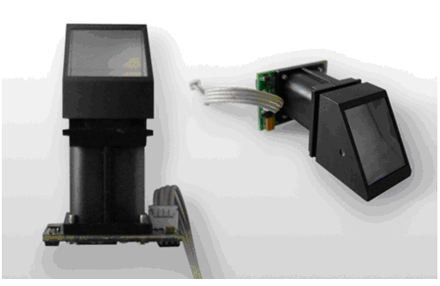
Fig 5.2 Fingerprint Reader

Specification of Finger Print reader:
- DC power: 3.6V-6V.
- Current working rate: 100mA-150mA.
- Time taken to acquire: <0.5sec.
- Average searching time: <0.8sec.
- Working environment:Temp -10°C - +40°C.
- Matching mode: 1:1 and 1:n matching.
Operation Principle OF Fingerprint Reader
Fingerprint processing includes two parts: fingerprint enrollment and fingerprint matching (the
matching can be 1:1 or 1:N). When enrolling, user needs to enter the finger two times. The system will process the two time finger images, generate a template of the finger based on processing results and store the template. When matching, user enters the finger through optical sensor and system will generate a template of the finger and compare it with templates of the finger library. For 1:1 matching, system will compare the live finger with specific template designated in the Module; for 1:N matching, or searching, system will search the whole finger library for the matching finger. In both circumstances, system will return the matching result, success or failure.
Fingerprint-processing instructions

- To collect finger image GenImg
Detecting finger and store the detected finger image in ImageBuffer while
returning successfull confirmation code; If there is no finger, returned confirmation code
would be “can’t detect finger”.
- Upload image UpImage
To upload the image in Img_Buffer to upper computer.
- Download the image DownImage
To download image from upper computer to Img_Buffer.
- To generate character file from image Img2Tz
To generate character file from the original finger image in ImageBuffer and store the file in CharBuffer1 or CharBuffer2.

- To generate Template
To combine information of character files from CharBuffer1 and CharBuffer2 and generate a template which is store back in both CharBuffer1 and CharBuffer2.
- To store template
To store the template of specified buffer (Buffer1/Buffer2) at the designated location of
Flash library.
- To read template from Flash library
To load template at the specified location of Flash library to template buffer CharBuffer1/CharBuffer2
- To delete template
To delete a segment (N) of templates of Flash library started from the specified location
- To empty finger library
To delete all the templates in the Flash library.
- To search finger library
To search the whole finger library for the template that matches the one in CharBuffer1
or CharBuffer2. When found, PageID will be returned.

POWER SUPPLY UNIT
The circuit needs two different voltages, +5V & +12V, to work. These dual voltages are supplied by this specially designed power supply. The power supply, unsung hero of every electronic circuit, plays very important role in smooth running of the connected circuit. The main object of this ‘power supply’ is, as the name itself implies, to deliver the required amount of stabilized and pure power to the circuit. The stabilization of DC output is achieved by using the three terminal voltage regulator IC. This regulator IC comes in two flavors: 78xx for positive voltage output and 79xx for negative voltage output. For example 7812 gives +12V output and 7912 gives -12V stabilized output. These regulator ICs have in-built short-circuit protection and auto-thermal cutout provisions. If the load current is very high the IC needs ‘heat sink’ to dissipate the internally generated power.
1 2 3
KIA 78xx
Series

Fig 6.1 voltage regulator
The microcontroller and other devices get power supply from AC to Dc adapter through 7812, 12 volts regulator. The adapter output voltage will be 12V DC non regulated. The 7805/7812 voltage regulators are used to convert 12 V to 5V/12V DC. Vital role of 7812 voltage regulator in this project .Finger print based system. The adapter output voltage will be 12V DC none regulated. The 7805/7812 voltage regulators are used to convert 12 V to 5V/12V DC
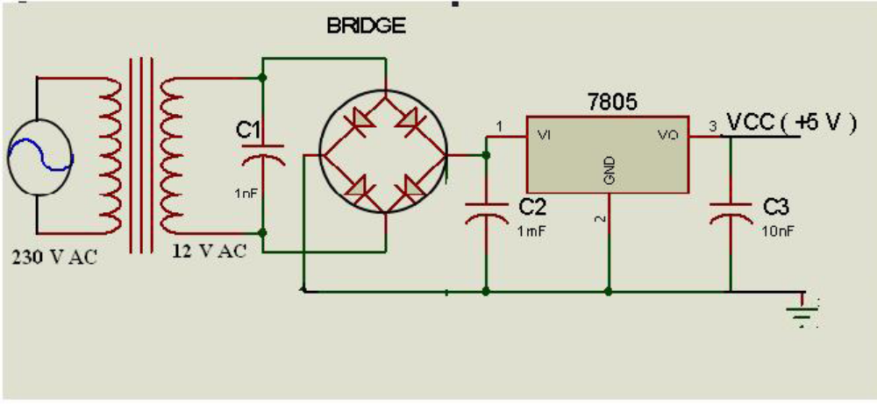
Fig : circuit diagram of voltage regulator
Circuit Description of Power supply unit
A DC power supply which maintains the output voltage constant irrespective of AC mains fluctuations or load variations is known as regulated DC power supply. It is also referred as full-wave regulated power. Supply as it uses two diodes with the transformer. This laboratory power supply offers excellent line and load regulation and output voltages of +5V & +12 V at output currents up to one ampere. Step-down Transformer: The transformer rating is 230V AC at Primary and 12-0-12V, 1Ampers across secondary winding. This transformer has a capability to deliver a current of 1Ampere, which is more than enough to drive any electronic circuit or varying load. The 12VAC appearing across the secondary is the RMS value of the waveform and the peak value would be 12 x 1.414 = 16.8 volts. This value limits our choice of rectifier diode as 1N4007, which is having PIV rating more than 16Volts.
Rectifier Stage: The two diodes D1 & D2 are connected across the secondary winding of the transformer as a full-wave rectifier. During the positive half-cycle of secondary voltage, the end A of the secondary winding becomes positive and end B negative. This makes the diode D1 forward biased and diode D2 reverse biased. Therefore diode D1 conducts while diode D2 does not. During the negative half-cycle, end A of the secondary winding becomes negative and end B positive. Therefore diode D2 conducts while diode D1 does not. Note that current across the centre tap terminal is in the same direction for both half-cycles of input AC. voltage. Therefore, pulsating DC. is obtained at point ‘C’ with respect to Ground.
Filter Stage: Here Capacitor C1 is used for filtering purpose and connected across the rectifier output. It filters the AC. components present in the rectified DC and gives steady DC voltage. As the rectifier voltage increases, it charges the capacitor and also supplies current to the load. When capacitor is charged to the peak value of the rectifier voltage, rectifier voltage starts to decrease. As the next voltage peak immediately recharges the capacitor, the discharge period is of very small duration. Due to this continuous charge-discharge-recharge cycle very little ripple is observed in the filtered output. Moreover, output voltage is higher as it remains substantially near the peak value of rectifier output voltage. This phenomenon is also explained in other form as: the shunt capacitor offers a low reactance path to the AC. components of current and open circuit to DC component. During positive half cycle the capacitor stores energy in the form of electrostatic field. During negative half cycle, the filter capacitor releases stored energy to the load.
Voltage Regulation Stage: Across the point ‘D’ and Ground there is rectified and filtered DC. In the present circuit KIA 7812 three terminal voltage regulator IC is used to get +12V and KIA 7805 voltage regulator IC is used to get +5V regulated DC output. In the three terminals, pin 1 is input i.e., rectified & filtered DC is connected to this pin. Pin 2 is common pin and is grounded. The pin 3 gives the stabilized DC output to the load. The circuit shows two more decoupling capacitors C2 & C3, which provides ground path to the high frequency noise signals. Across the point ‘E’ and ‘F’ with respect to ground +5V & +12V stabilized or regulated DC output is measured, which can be connected to the required circuit.

EEPROM (Electronically erasable PROM)
EEPROM means Electrical Erasable Programmable Read Only Memory and also referred to as E²PROM chip or I2C. As the name suggest, an EEPROM can be both erased and programmed with electrical pulses from a programmer kit, burner or the equipment itself. Since it can be both electrically written into and electrically erased, the EEPROM IC can be quickly programmed and erased in circuit for reprogramming without taking them out from the main board.EEPROM IC is also called a non-volatile memory because when the power is switched off, the stored data (information) in the EEPROM IC will not be erased or corrupt and the data is still intact. New EEPROM IC have no data (blank) inside and normally have to program it first with a programmer tools before it can be use on electron IC circuit.
If you just installed a new or blank EEPROM IC into a main board, even though with the same part number, I can say that the equipment will surely not going to work because the CPU or microprocessor do not know how to function. Information or data stored in this type of memory can be retained for many years even without a continuous dc power supply to the IC.
Application/ Operation of EEPROM
EEPROMs mainly store user programmable information such as:
- VCR programming information or data.
- CD programming information or data.
- Digital satellite receiver control data or information.
- User information on various consumer products such as in Television.
The EEPROM IC in Computer Monitor performs two tasks:
- When a monitor is turn on it will copies all the data or information from the EEPROM to the microprocessor or CPU. For instance, the EEPROM will let the CPU know the frequencies at which the monitor is going to run.
- The EEPROM IC is used to store the current settings of the Monitor. The current settings of the monitor will not be erased even when the monitor is switched off. Anytime when a change is made in the monitor settings, the CPU updates the setting in the EEPROM (store data in EEPROM). When the monitor is switch on again, the stored settings in EEPROM IC are used to set up the monitor for operation.
Assuming the data file in MONITOR or TV’s EEPROM are corrupted damaged and failure detected, what would be the display symptoms like?
- There would be no high voltage (no display) because the CPU don’t activate the 12 volt line supply to the horizontal and vertical oscillator IC.
- The IC will not save (store) the current setting of the equipment
- Some control functions like sound, brightness, horizontal size and contrast control will not work.
- The On Screen Display (OSD) would not work or the OSD will have a corrupted or erratic display.
- Equipment high voltage will shut down (EEPROM set wrongly the horizontal frequency and will lead to a failure of the horizontal output transistor (HOT)).
16X2 LCD DISPLAY
LCD stands for Liquid Crystal Display. The most commonly used LCDs found in the market today are 1 Line, 2 Line or 4 Line LCDs which have only 1 controller and support at most of 80 characters.

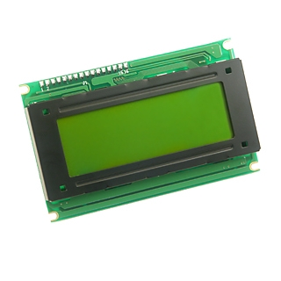
Fig 6.3.2 16x2 LCD Display

DDRAM - Display Data RAM - Display data RAM (DDRAM) stores display data represented in 8-bit character codes. Its extended capacity is 80 X 8 bits, or 80 characters. The area in display data RAM (DDRAM) that is not used for display can be used as general data RAM. So whatever you send on the DDRAM is actually displayed on the LCD.

PIN DESCRIPTION of LCD
Most LCDs with two controllers has 16 Pins. Pin description is shown in the table below.

Pin No. | Name | Description
Pin no. 1 | D7 | Data bus line 7 (MSB)
Pin no. 2 | D6 | Data bus line 6
Pin no. 3 | D5 | Data bus line 5
Pin no. 4 | D4 | Data bus line 4
Pin no. 5 | D3 | Data bus line 3
Pin no. 6 | D2 | Data bus line 2
Pin no. 7 | D1 | Data bus line 1
Pin no. 8 | D0 | Data bus line 0 (LSB)
Pin no. 9 | EN1 | Enable signal for row 0 and 1 (1stcontroller)
Pin no. 10 | R/W | 0 = Write to LCD module  1 = Read from LCD module
Pin no. 11 | RS | 0 = Instruction input  1 = Data input
Pin no. 12 | VEE | Contrast adjust
Pin no. 13 | VSS | Power supply (GND)
Pin no. 14 | VCC | Power supply (+5V)
Pin no. 15 | EN2 | Enable signal for row 2 and 3 (2ndcontroller)
Pin no. 16 | NC | Not Connected
Table6.3.3 Pin description of the LCD

Sending Commands to LCD
To send commands we simply need to select the command register. Everything is same as we have done in the initialization routine. But we will summarize the common steps and put them in a single subroutine.
Following are the steps:
- Move data to LCD port
- Select command register
- Select write operation
- Send enable signal
- Wait for LCD to process the command

DC MOTOR
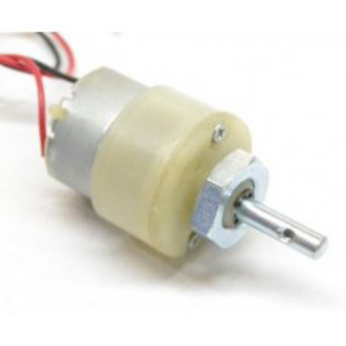
Fig : DC Motor
A DC motor is an electric motor that runs on direct current power. In any electric motor, operation is dependent upon simple electromagnetism. A current carrying conductor generates a magnetic field, when this is then placed in an external magnetic field, it will encounter a force proportional to the current in the conductor and to the strength of the external magnetic field. A DC motor is any of a class of rotary electrical machines that converts direct current electrical energy into mechanical energy. It works on the fact that a current carrying conductor placed in a magnetic field experiences a force which causes it to rotate with respect to its original position. Nearly all types of DC motors have some internal mechanism, either electromechanical or electronic, to periodically change the direction of current flow in part of the motor. DC motors were the first form of motor widely used, as they could be powered from existing direct-current lighting power distribution systems. A DC motor’s speed can be controlled over a wide range, using either a variable supply voltage or by changing the strength of current in its field windings. Small DC motors are used in tools, toys, and appliances.

FLOW CHART

Start
(POWER ON)

Control unit reads the status of microcontroller
If F1?
LCD displays “Login as Admin”
If Admin?
Unlock Door
LCD Displays “Valid User”
Stop
B

Advantages and Disadvantages
Advantages:

- Easy to implement
- Avoids Theft
- Simple to use
- Cost effective

Disadvantages:
- Maintenance required

Chapter 9
CONCLUSION AND FUTURE WORK

The main advantages of using this system are:
1. Easy to use and requires no special training or equipment.
2. Fingerprint is unique for every person it cannot be imitated or fabricated .It is not same in the case of twins also.
3. High accuracy in terms of security.
4. No manual errors.
5. No false intrusions A step by step approach in designing the microcontroller based system for securing the transactions of the user and providing the security for the locker system and even more for the PASSPORT verification using a finger print scanner has been followed.
The result obtained in providing the security is quite reliable in all the three modes. The system has successfully overcome some of the aspects existing with the present technologies, by the use of finger print Biometric as the authentication Technology.

REFERENCES
[1] Signals, Systems and Computers, 2004 Conference Record of the Thirty-Eighth Asilomar Conference on Publication 7-Nov-2004 Volume: 1, on page(s): 577-581 Vol.1.

[2] International Journal of Advanced Research in Computer Science and Software Engineering, Volume 2, Issue 10, October 2012.

[3] International Journals of Biometric and Bioinformatics, Volume (3): Issue (1).

[4] Mukesh Kumar Thakur, Ravi Shankar Kumar, Mohit Kumar, Raju Kumar “Wireless Fingerprint Based Security System using Zigbee” , International Journal of Inventive Engineering and Sciences (IJIES) ISSN: 2319–9598, Volume-1, Issue-5, April 2013.

[5] Mary Lourde R and Dushyant Khosla, “Fingerprint Identification in Biometric Security Systems”, International Journal of Computer and Electrical Engineering, Vol. 2, No. 5, October, 2010.

[6] “Fingerprint Matching” by Anil K. Jain, Jianjiang Feng and Karthik Nandakumar, Department of Computer Science and Enginnering, Michign State University. About Authors:A.Aditya Shankaris a final year undergraduate student, Dept. Of Electronics and Communication Engineering from Dadi Institute of Engineering and Technology, Visakhapatnam,Andhra Pradesh. His main areas of interest are Sensor Technology, Analog and Digital Circuits, Embedded Systems andWireless Communication &Networking.

